The Role of Artificial Intelligence in the Modern Power Systems

G Kumar Venayagamoorthy, PhD, MBA, FIEEE, FIET, FSAIEE

Abstract
The modern power system is complex and one that is expected to be conscious, intelligent, distributed, and flexible. Such an electric power system architecture can facilitate secure and distributed flow of power from renewable energy sources including solar and wind. Furthermore, it can handle flexible loads and energy storage including electric vehicles. This talk will address the potentials and promises of Artificial Intelligence (AI) for power system operations and control. AI has evolved over the last 40 years to transform operations and control of complex systems. A modern power system with variable power and energy sources, bidirectional power flows, and uncertainty in forecasting and real- time availability of generation, loads, energy storage and other operational resources requires intelligent technologies for its operation and control. Examples of AI technologies for stable, secure, reliable, and efficient operations and control of power systems will be presented.

Biography of Speaker

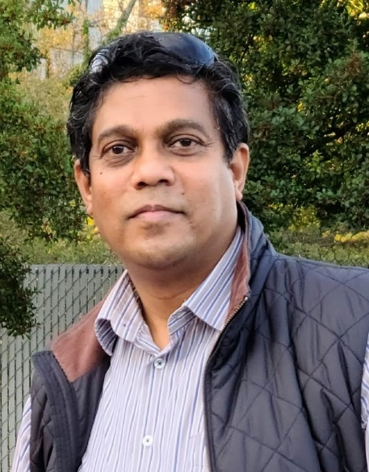
Ganesh Kumar Venayagamoorthy is the Duke Energy Distinguished Professor of Power Engineering and Professor of Electrical and Computer Engineering at Clemson University since January 2012. Prior to that, he was a Professor of Electrical and Computer Engineering at the Missouri University of Science and Technology (Missouri S&T), Rolla, USA where he was from 2002 to 2011, and a Senior Lecturer in Department of Electronic Engineering, Durban University of Technology, Durban, South Africa, where he was from 1996 to 2002.
Dr. Venayagamoorthy is the Founder (2004) and Director of the Real-Time Power and Intelligent Systems Laboratory. Dr. Venayagamoorthy received his PhD and MScEng degrees in Electrical Engineering from the University of Natal, Durban, South Africa, in April 2002 and April 1999, respectively. He received his BEng degree with a First-Class Honors in Electrical and Electronics Engineering from Abubakar Tafawa Balewa University, Bauchi, Nigeria in March 1994. He holds an MBA degree in Entrepreneurship and Innovation from Clemson University, SC (August 2016).
Dr. Venayagamoorthy’s interests are in research, development and innovation of smart grid and artificial intelligence technologies. He is a 2004 US NSF CAREER Awardee, a 2007 US Office of the Naval Research (ONR) Young Investigator Program (YIP) Awardee, and a 2008 NSF Emerging Frontiers in Research and Innovation (EFRI) Awardee. He led the brain2grid project funded by US National Science Foundation (NSF). Dr. Venayagamoorthy is an inventor of technologies for scalable computational intelligence for complex systems and dynamic stochastic optimal power flow. He has published over 550 refereed technical articles which are cited over 20,000 times with a h-index of 67 and i10-index of > 280. Dr. Venayagamoorthy has given over 500 invited technical presentations including keynotes and plenaries in over 40 countries to date.
Dr. Venayagamoorthy is involved in the leadership and organization of conferences including the Clemson University Power System Conference and Pioneer and Chair/co-Chair of the IEEE Symposium of Computational Intelligence Applications in Smart Grid (CIASG) since 2011. He is currently the Chair of the IEEE PES Working Group on Intelligent Control Systems, and the Founder and Chair of IEEE Computational Intelligence Society (CIS) Task Force on Smart Grid. He has served/serves as Editor/Associate Editor/Guest Editor of several IEEE Transactions and Elsevier Journals. He is the Editor for the IEEE Press Series on Power and Energy Systems.
Dr. Venayagamoorthy has received several awards for faculty, research and teaching excellence from universities, professional societies, and organizations. Dr. Venayagamoorthy is a Fellow of the IEEE, IET and the South African Institute of Electrical Engineers (SAIEE), and a Senior Member of the International Neural Network Society.

