Short CV
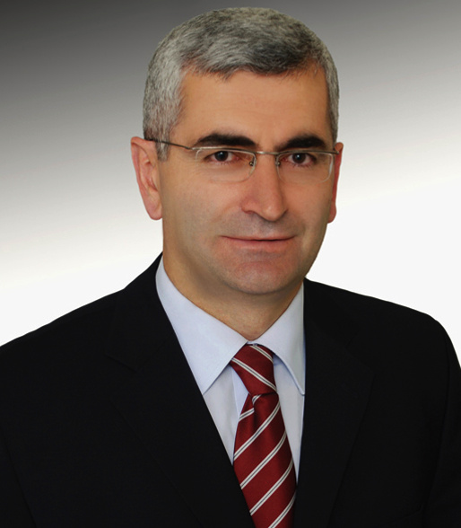
ILHAMI COLAK was born in 1962 in Turkey. He received his diploma in Electrical Engineering from Gazi University, Turkey in 1985. Then he did his MSc in Electrical Engineering in the field of Speed Control of Wound Rotor Induction Machines Using Semiconductor Devices at Gazi University in 1991. After that he did his MPhil at Birmingham University in England by preparing a thesis on High Frequency Resonant DC Link Inverters in 1991. Finally, he did his PhD at Aston University in England on Mixed Frequency Testing of Induction Machines Using Inverters in 1994. He became an assistant professor, an associate professor and a full professor in 1995, 1999 and 2005 respectively.
He has published more than 98 papers, 220 conference papers, and 7 books in different subjects including electrical machines, drive systems, machine learning, reactive power compensation, inverter, converter, artificial neural networks, distance learning automation and alternating energy sources.
More than 186 of his papers have been cited in SCI. His papers have received more than 1994 citations by 1759 papers. His Thomson Reuters h-index is 23 and average citation per paper is 10.72.
In SCOPUS, h-index is 28. His 243 papers have received 3062 citations from 2655 authors.
He supervised 23 MSc students and 14 PhD students. He is a senior member of IEEE, members of IES, IAS, PELS and PES. Last twenty years, he has been concentrated his studies on renewable energy and smart grids by publishing papers, journals (www.ijrer.org) (www.ijSmartGrid.org) and organizing international IEEE sponsored conferences (www.icrera.org), (icSmartGrid.org). He also spent around 3 years at European Commission Research Centre (JRC) in Netherlands. He served as the head of department, dean and vice rector at Gazi University, Istanbul Gelisim University and Nisantasi University. He is currently a full professor at Nisantasi University.
ilhcol@gmail.com;
icolak@gazi.edu.tr;
ilhami.colak@nisantasi.edu.tr
http://w3.gazi.edu.tr/~icolak/english.htm
https://akademik.yok.gov.tr/AkademikArama/view/viewAuthor.jsp

